**Database Design:**

The database of Boba Shop Management System has an operational module and analytical module.

1. **Operational Module**

The Boba Shop Management System uses a MySQL database to manage and store its data pertaining to the day-to-day operations of the boba shop. The database is designed to adhere to the normalization technique and all the tables are in 1NF. It consists of total 10 entities/tables viz customer, employee, employee phone number, vehicle, tea, topping, orders, order details, store and sells. These tables are designed to gather and organize all the data related to the basic operations of a boba shop. Further they also serve the purpose to look into analytics of the business operations.

To design the database, the website erdplus was used.

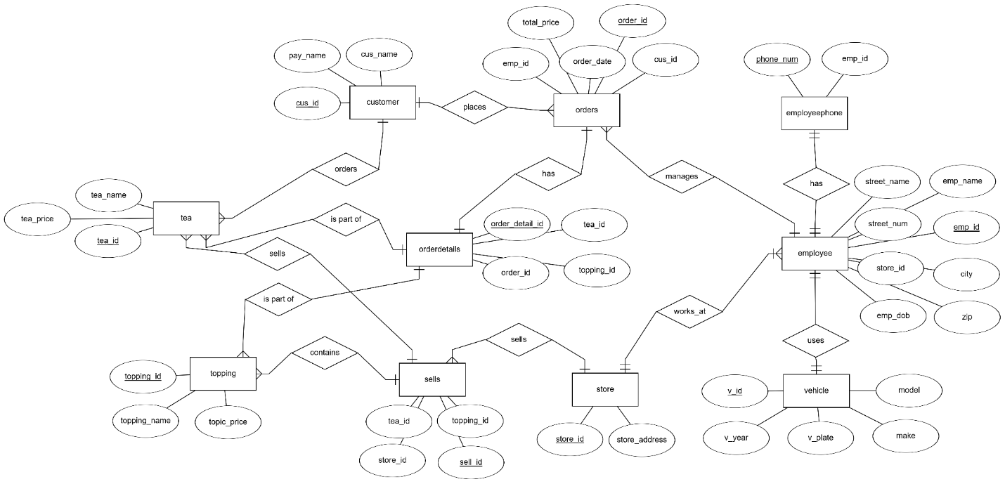**Figure: ER DIAGRAM**

A comprehensive table explaining the figure- ER Diagram

|  |  |  |
| --- | --- | --- |
| **Entity** | **Attributes** | **Purpose** |
| Customer | cus_id, cus_name, pay_name | Stores customer information and their preferred payment methods. |
| Employee | emp_id, emp_name, emp_dob,  store_id, city, street_name, streen_num, zip | Records information about employees and their assigned stores |
| Employee Phone Number | Phone_num, emp_id | Contains primary phone numbers of each employee |
| Vehicle | v_id, model, make, v_plate, v_year | Contains details of the vehicles owned by the employees |
| Tea | Tea_id, tea_name, tea_price | Contains details about available teas including prices |
| Topping | Topping_id, toppin_name, toppong_price | Contains details about available toppings including prices |
| Orders | Order_id, order_date, cus_id, emp_id, total_price | Tracks customer orders, including the responsible employee and total price. |
| Order details | Orderdetail_id, order_id, tea_id, topping_id | Provides detailed information on each order, linking teas and toppings. |
| Store | Store_id, store_address | Record of various stores and their location |
| Sells | Tea_id, toppin_id, store_id, sell_id | Tracks the tea and topping sold by various stores |

The corresponding relational schema of figure: ER DIAGRAM is shown below:

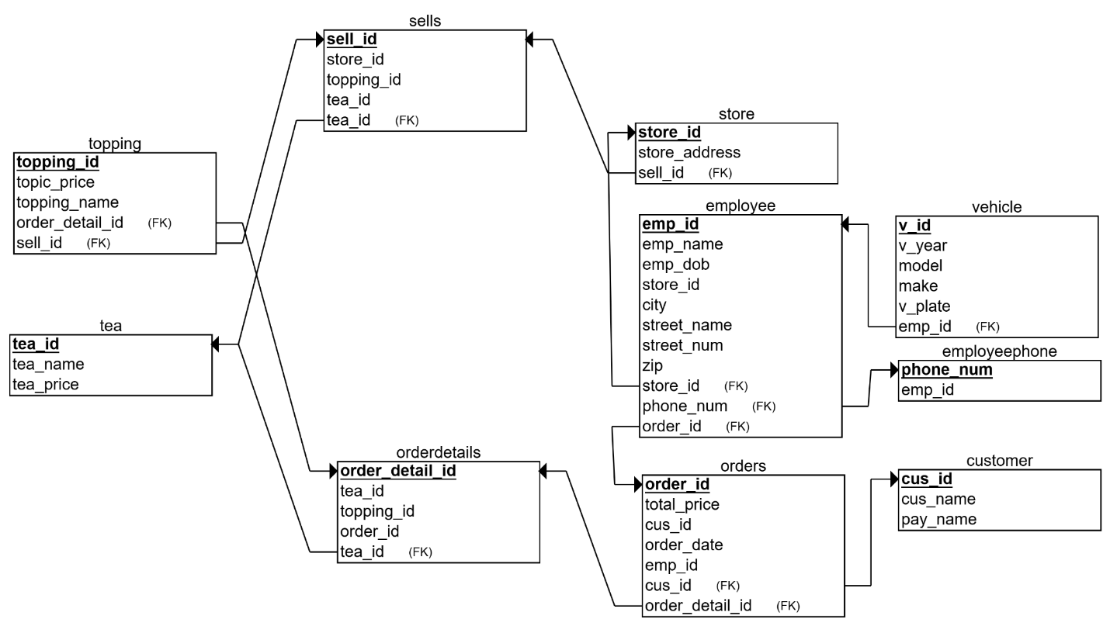

**Figure: RELATIONAL SCHEMA**

**A-1 : Working of the operational module:**

Insert landing page of boba shop here

The landing page of the graphical user interface prompts user to choose among employee portal, manager portal and exit.

**Figure:GUI- Landing Page of Application**

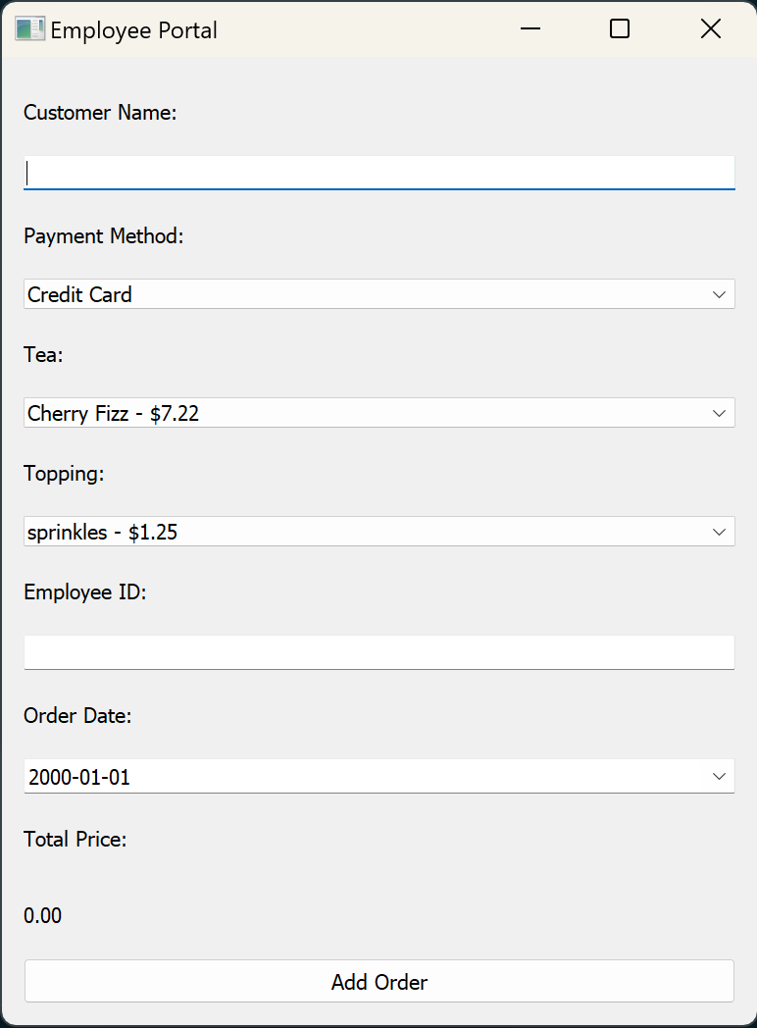

Clicking on the employee portal takes us to the order entry page. Here we can take a new order from a walk-in customer by entering the required field.

**Figure: GUI- Employee portal**

In summary, the employee portal is used to create a fresh order and the corresponding entries are entered in their respective tables of the database. The total amount by adding the prices of tea and topping are displayed at the end before finalizing the order.

1. **Analytical Module**

The analytical module delivers insightful reports to review and aid in the business operations like sales reports, employee performance reports, most loved tea or topping.

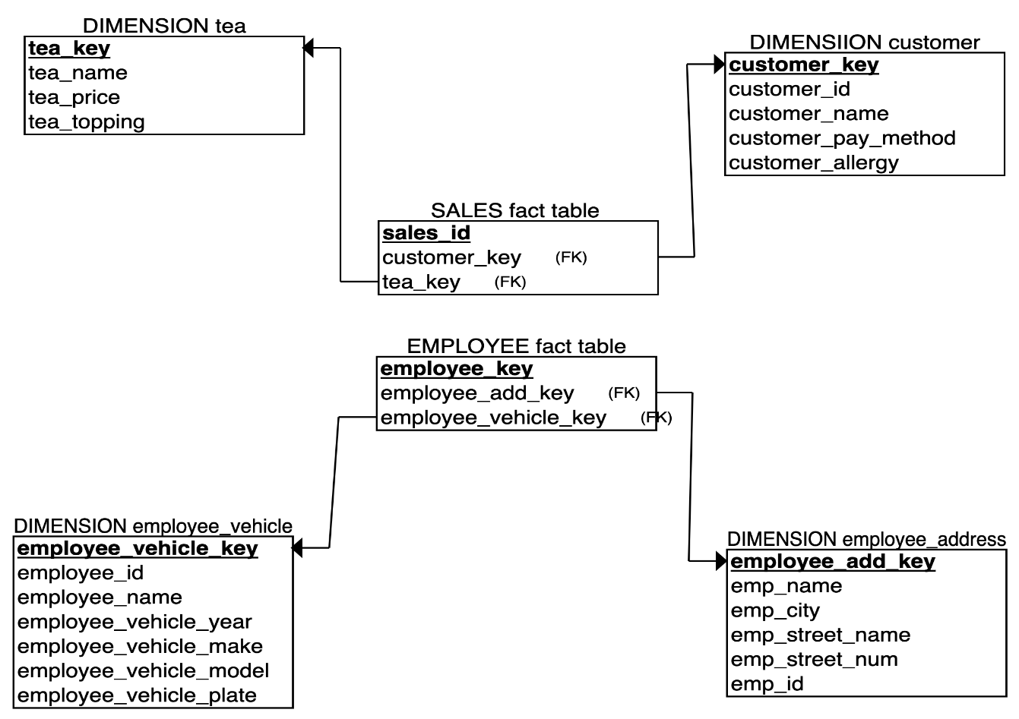

**Figure: STAR SCHEMA**